Snohomish Radio Aero Club 2023 Membership Application

NOTE: AMA & SRAC memberships (including flying privileges) expire annually on December 31st.
NOTE: Application for membership is not complete until AMA registration has been verified.
NOTE: Ability level: New members will be listed as Training until verified by a flight instructor.
Payments may be attached to application OR paid through PayPal using link at https://www.sracinc.org/membership

------------------- Adult or Youth Applicant -----------------------
Membership Type | Club Dues | Field Use Fee | Total Paid
AMA Number Ability Level
First Name Last Name
Phone number Date of Birth
Email Note: Print email address CAREFULLY
Address
City Zip
Emergency Contact FN & LN (if different)
Phone number
“I have read and agree to comply with the AMA Safety Code and all SRAC field rules and safety regulations. I am aware that modeling may present hazards to participants and spectators. I exempt, waive, and relieve SRAC, its officers and field owners from all current or future liability for personal injury, property damage, or wrongful death.”

Signature Date

Membership Type  --- Partner OR Junior Applicant --- | Club Dues | Field Use Fee | Total Paid
AMA Number Ability Level
First Name Last Name
Phone number Date of Birth
Email Note: Print email address CAREFULLY
“I have read and agree to comply with the AMA Safety Code and all SRAC field rules and safety regulations. I am aware that modeling may present hazards to participants and spectators. I exempt, waive, and relieve SRAC, its officers and field owners from all current or future liability for personal injury, property damage, or wrongful death.”

Signature Date

Registrars: Mr. William Renfro……….. 511 – 72nd St. SE, Everett, WA 98203 425-347-6780
Mr. Chris Christensen …….. 19628 - 118th St S.E., Snohomish, WA 98290 425-501-1779
President: David Pitkin 425-327-9458 Treasurer: Marty Menia 425-418-8692
New Members

Mail check made out to SRAC along with both pages to:
Marty Menia
11107 25TH ST NE
LAKE STEVENS, WA 98258-9130

OR
Scan or photograph both pages.
Then email to: Marty Menia
SRAC501c3@gmail.com
Then pay via PayPal using
https://www.sracinc.org/newmembers1

- NEW MEMBERS: Send this page AND the application to the address listed at the bottom of the application.
- Pay via PayPal (use links) OR Checks should be made out to SRAC inc. OR Snohomish Radio Aero Club.
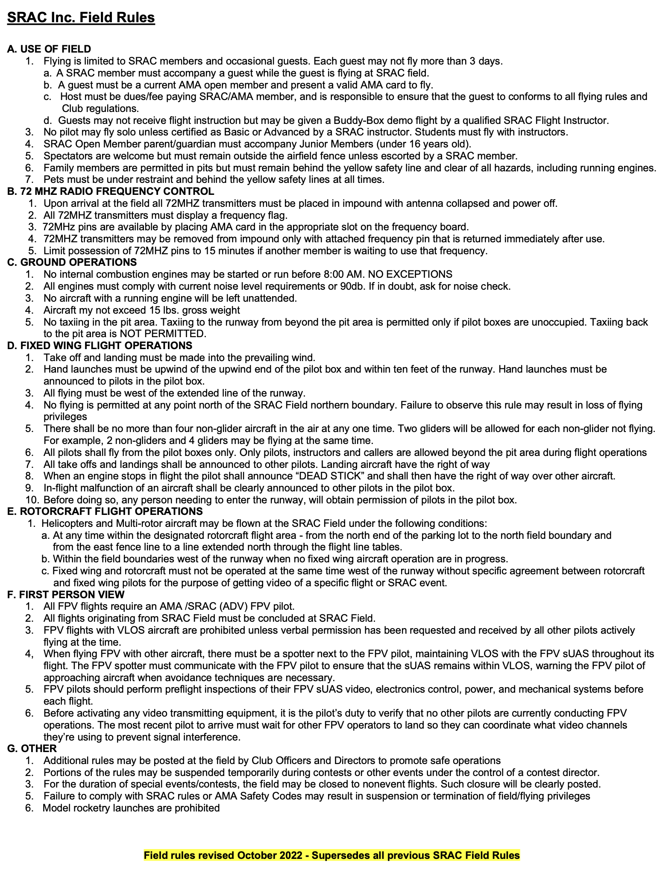
- Signature on page one verifies that you have read and agree to the following. Application will be kept on file. Future verification will not be necessary.

